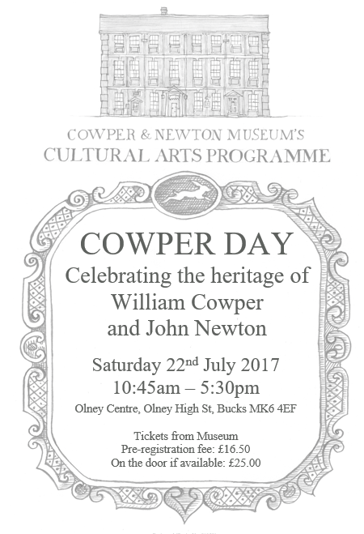
Registered Charity No. 310521
PROGRAMME  From 10:45 Coffee  11:15 Welcome from the chairman  11:20 – 12 noon Dr Mark Crosby, Kansas State University: Cowper, Blake, and Hayley: the museum’s two William Blake miniatures  12:05 – 12:45 Dr Katherine Turner, Professor of English, Mary Baldwin University, Virginia:  "This folio of four pages, happy work!" - Cowper and the newspapers  12:45 – 13:45 LUNCH AT THE OLNEY CENTRE  13:45 – 14:15 Panel: some new aspects of the collection  14:15 – 14:45 Talk by James Brannan on his ancestor Sam Roberts: Sam Roberts of Weston, Cowper's 'Faithful Attendant'  Short break  15:00 – 15:45 Marylynn Rouse, The John Newton Project: ‘Keeping up with the Jones’s’ - the recently rediscovered correspondence between John Newton and Robert Jones of Hull, goldsmith  16:15 – 17:30 RECEPTION IN THE MUSEUM GARDEN, AND LATE OPENING OF THE MUSEUM |  |  | COWPER DAY REGISTRATION FORM  Saturday 22 July 2017  Please complete this form to book your place at this year’s Cowper Day event. * You will receive a confirmation email.  For planning purposes we ask you to pre-register. Your pre-registration fee of £16.50 covers morning coffee, a sandwich lunch on the day, and the late afternoon reception at the museum.  The charge for those who pay on the day, if there is space, will be £25.00.  Name/Names:  Address:  Postcode:  Email address:  Telephone number:  Single Registration £16.50  Dual Registration £33.00  Are you already a Friend of the Museum? YES / NO  Please choose preferred Payment Method  Cash  Cheque (made payable to ‘Cowper and Newton Museum’  Credit card (please ring the museum for further instructions)  If returning this form by post with a cheque please return to:  COWPER DAY 2017  The Cowper and Newton Museum  Orchard Side, Market Place  Olney, Bucks. MK46 4AJ  We look forward to seeing you on Saturday 22 July 2017  Please email your booking form to:  house-manager@cowperandnewtonmuseum.org.uk

